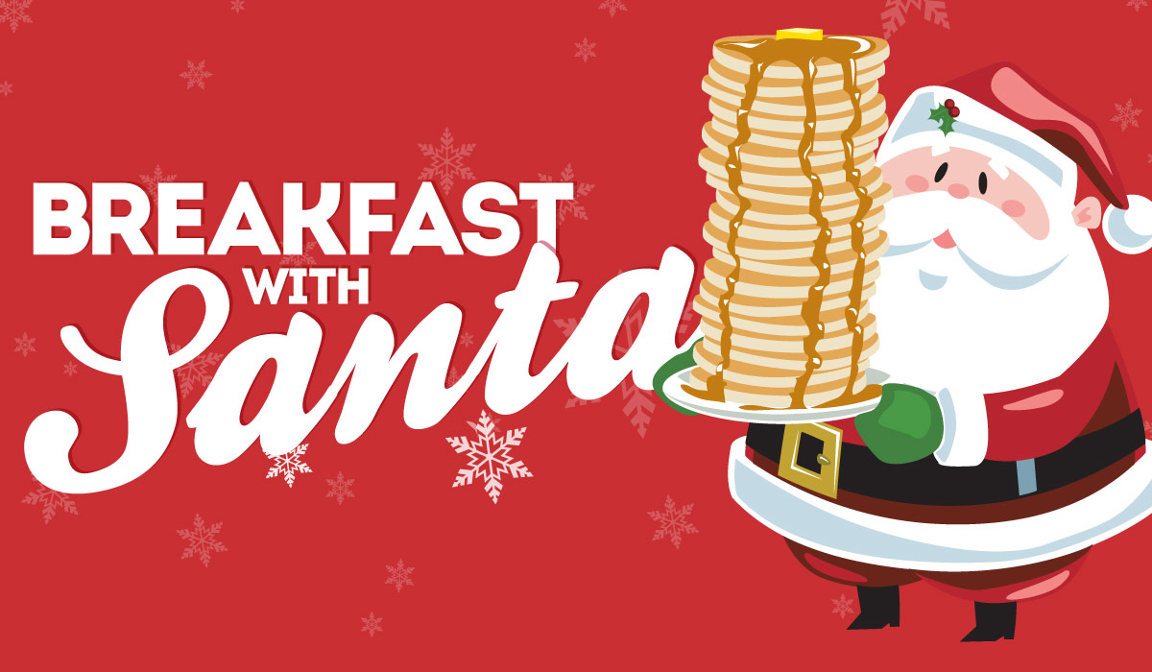
CENTER SCHOOL PTO PRESENTS:

SATURDAY, DECEMBER 8TH Ticket Price:
9:00 AM to 11:00 AM $10 per person
Center School Cafeteria Under 3 is Free

Santa is coming to Center School and he wants to have breakfast with you! Bring the whole family for some holiday fun and breakfast buffet with Santa and his helpers!
Admission includes a catered breakfast, crafts, and meet & greet with Santa!
There are a limited number of tickets for this event and they will be sold on first come first serve basis.
Please turn in the form with payment of cash or check made payable to “Center School PTO” * Forms and payment must be returned by Friday, 11/30/18
*Children 2 years old and younger are free. There is a family cap of $50.00 for immediate/nuclear family only.
If you have any questions please contact Jamie McCarthy at jwylot@pjlodola.com
---------------------------------------------------------------------------------------------------------------
Parent Name:_____________________________________________ Email:_________________________________
Student Name:____________________________________________ Tel #:__________________________________
Teacher Name:____________________________________________ # Kids 2 & under (free):____________
# Kids Tickets (ages 3-12) $10ea :____________ # Adult Tickets (13 +) $10ea :______________

