

Mayo Elementary School

Season Begins: March 27th

Days & Times: Tuesdays 2:50-3:50

Fee : $75.00

5K Race day: Sunday May 20th @9am

Location: AACounty Fairgrounds

***For questions please email kellylaye@hotmail.com***

SPACE IS LIMITED. REGISER TODAY AT:

www.heroboys.org

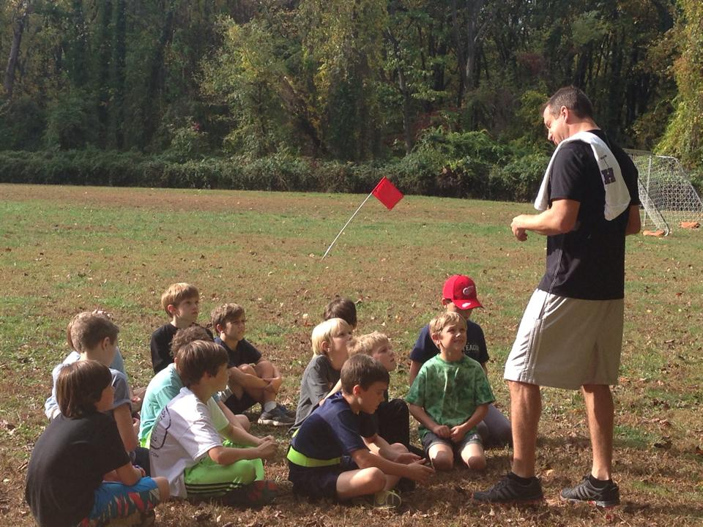

ERO Boys is a youth development and engagement program for boys in 3rd – 5th grades. Using running as a base activity HERO Boys inspires boys to discover the character and courage that resides inside each one of them to be brave, stand for that which is right, and use their talents and strengths to lead and set the positive example amongst their peers. The school-based program is 8 weeks long and culminates with the HERO Boys 5K including boys from all schools participating in the program.

**H**

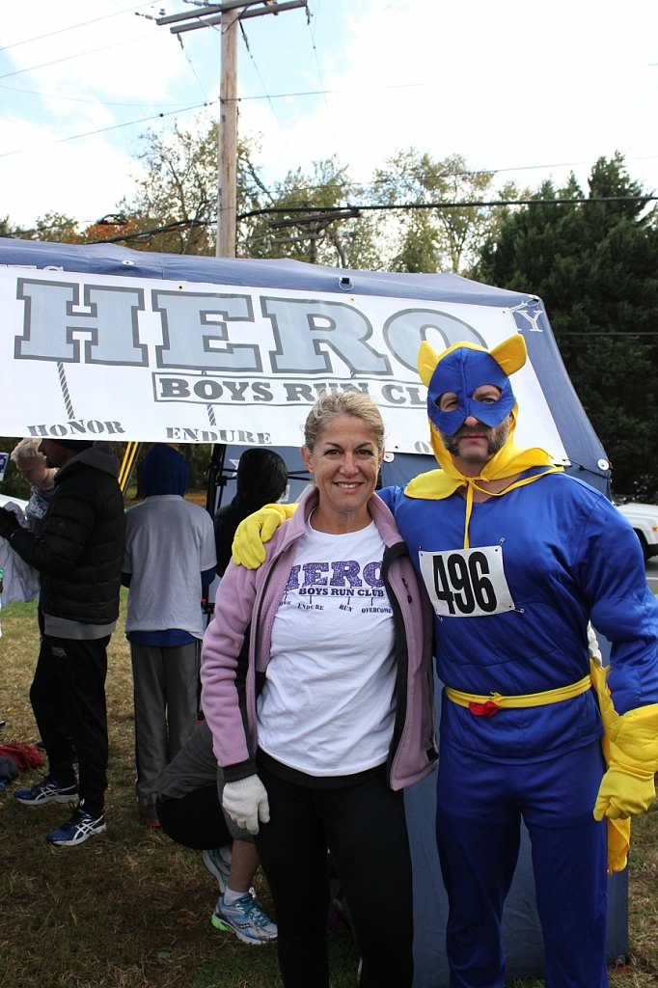

**DISCOVER THE HERO WITHIN**

