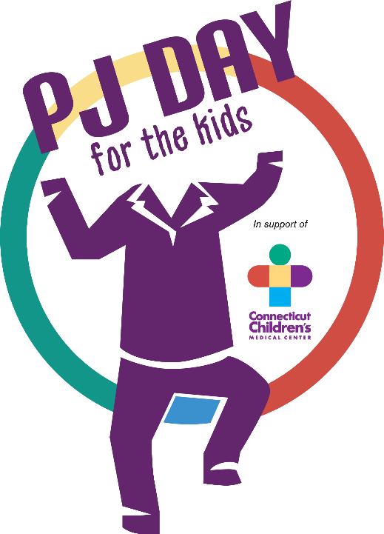

Wear your pajamas to school Friday, December 8th in support of patients at Connecticut Children’s Medical Center!!

Students and staff of Center School are invited to wear their PJ’s to school in honor of kids at Connecticut Children’s Medical Center. Thousands of children each year spend days, weeks, or longer in PJ’s at the hospital while receiving care. PJ Day for the Kids will help us show our support for these brave kids!
Wear your pjs and make a donation of $1 or more.
Donations will be collected at school on Friday, December 8th.
For more information, and to locate the Center School team to make an online donation, visit: give.connecticutchildrens.org/pjday

Checks can be made to Connecticut Children’s Medical Center Foundation.
All proceeds benefit The Center for Cancer and Blood Disorders at
Connecticut Children’s Medical Center.

For any questions, please contact Kim Hough at kimhough1@gmail.com

