The CGES Spring 2020 Scholastic Book Fair is coming!
Please check out our new and improved online Book Fair page
https://bookfairs.scholastic.com/bf/collegegardenselementarysch

The Scholastic Book Fair is returning to College Gardens Elementary School March 2nd – March 6th, 2020. This is a great opportunity to stock your shelves while supporting our school and putting more books in each classroom.

Book Fair Hours (in Main Lobby)
Monday, March 2nd 9:00 AM – 4:00 PM
Tuesday, March 3rd 9:00 AM – 6:00 PM
SPECIAL EVENT: Family Fun Night 7:00 PM – 8:30 PM
Wednesday, March 4th 9:00 AM – 6:00 PM
Thursday, March 5th 9:00 AM – 6:00 PM
Friday, March 6th 9:00 AM – 12:00 Noon

Special Events
In Spring 2020 we have decided to bring back everyone’s favorite event Family Fun Night! It will be held in in APR on Tuesday, March 3rd, 2020 from 7 to 8:30 PM. Come explore the Book Fair with your family, participate in ruffle, make a craft and enjoy some Carmen’s ice cream!

Extended Hours
The Book Fair will be open later than usual from 4:00-6:00 PM on Tuesday, Wednesday and Thursday. We are inviting families to come shop the fair after school hours while picking up kids from Bar-T and afterschool activities. Please stop in to check out our great selection of books and gifts!

We need Volunteers!
We can’t pull this off without your help, even if you have never volunteered before, this is the time to do it! We need help before and after school as well as during the school day for class visits. If you want to help out please sign up through SignUpGenius
https://www.signupgenius.com/go/4090E45AFA82AA6F94-please3
or contact Natalia Hilliard at hilliardmn@starpower.net.
Anyone and everyone is welcome, whether you can come for an hour or stay for a day, please consider pitching in!

Purchasing Books during Class Visits to the Fair and eWallet
With parents’ permission, students can purchase books on their own during their visit, we accept cash, checks and eWallet. Please refrain from sending your child to school with you credit card. All checks should be made payable to CGES PTA.

eWallet is simple and great way to let your child shop the book fair cash free. You, as parent, provide billing information on the Scholastic website and set spending limit for your student, Book Fair doesn’t bill you until your student actually buys the books and only for the amount of purchase up to the spending limit. Please refer to the back of this letter for additional information and FAQs.

If you prefer to send cash or check for the younger children, please place it in an envelope and write the teacher’s name and child’s name on the front of the envelope when you send it to school with your child.

Student Wish Lists
If students do not have money when they visit the Book Fair, they will have the opportunity to fill out a wish list. When returning the wish list to school, please indicate whether a book of similar price may be substituted if the original requested book is no longer available. We accept cash, checks and eWallet. All checks should be made payable to CGES PTA.

Classroom Wish Lists
Each teacher has a wish list of books they think would be a great addition to their classroom libraries. Please ask a volunteer where to find your teacher’s classroom wish list when you visit the fair.
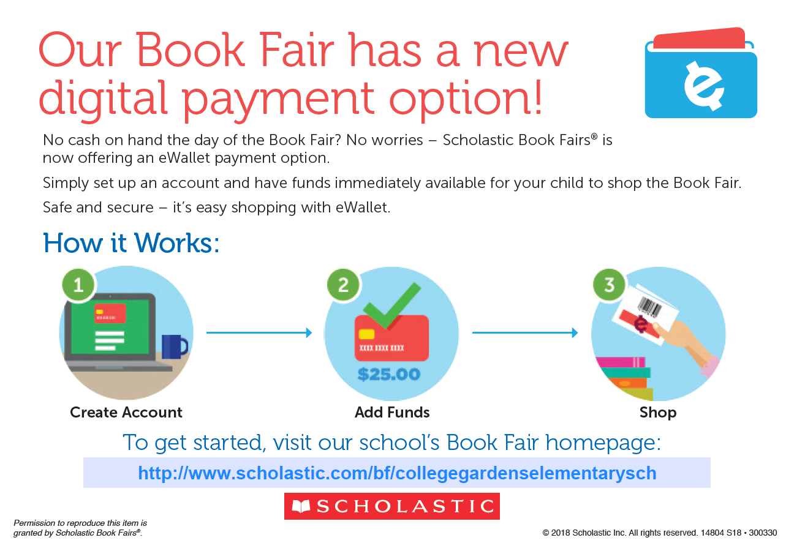
https://bookfairs.scholastic.com/bf/collegegardenselementarysch
Book Fair eWallet FAQs

What is a Book Fair eWallet?
eWallet is a new, digital payment option that gives your school community a secure, cash-free way to shop the fair. Parents can pre-authorize a spending amount online, which can be looked up or scanned at checkout.

Is there a fee for creating an eWallet?
There is no charge to create an eWallet; it is a free service for your school community.

Is there a minimum or maximum amount of funds that can be loaded to an eWallet?
There is a $10 minimum in order to set up an account. There is no maximum amount.

Can parents create one eWallet for all of their children?
No, parents must create an eWallet for each student; accounts cannot be shared or transferred.

How are parents charged for eWallet purchases?
A preauthorization charge will appear on the credit card account in the amount parents select as the eWallet spending limit. Parents will only be charged for what is purchased at the fair (up to the spending limit they selected). Any unspent funds will be released back to the credit card after the fair ends.

Can parents add additional funds to an existing eWallet?
Yes, additional funds can be added to the eWallet at any time.

Can parents delete an existing eWallet?
Yes, parents can delete eWallets and any unspent funds would be returned to their credit card.

Can extended family members setup an eWallet account?
Yes, anyone can set up an eWallet account for a student, so a student may have multiple eWallets to utilize. You may want to suggest eWallets to extended family members who are unable to attend the book fair and still want to support your student.

How will I know if any eWallets have been setup?
When the first eWallet account has been setup, you will receive an email notification. No other emails will be sent, regardless of the number of eWallets created.

