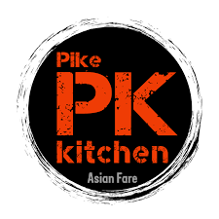
College Gardens
Dine Out Night
At
Pike Kitchen

1066 Rockville Pike, Rockville, MD 20852
Tuesday, December 10
3 to 8 pm

15% of the proceeds will go to College Gardens

If you haven’t tried Pike Kitchen yet, now is the perfect time!

Pike Kitchen is an Asian food hall with a variety of Asian cuisines. It is a great place to grab a quick dinner with lots of options for everyone.

Some of the vendors include: Bowl Play for Korean bibimbap and Hawaiian poké bowls; Pike Bakery for Korean baked goods and coffee; Monster Tea for bubble tea stand; J Viet for pho and banh mi; Japomen for ramen counter; Pike Chicken & Beer for boneless fried chicken and drafts; K Street for Thai street food and kimchi tacos; and Kogyro for thinly sliced meats and platters.
