You are formally invited to attend the Palm Beach County Council of PTA/PTSA’s
Reflections Celebration!

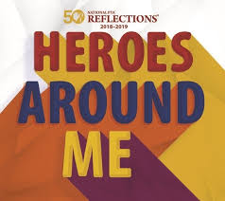

February 4, 2019
5:30pm- Palm Beach County Council of PTA/PTSA’s
2nd General Meeting and Pizza Served (Optional)
6:30pm- Reflections Awards Ceremony
Safe Schools Institute @ Don Estridge Middle School Campus
1790 Spanish River Blvd.
Boca Raton, FL 33431

Every school winner will receive a medal and
every school will receive a special thank you gift.
County winners will receive trophies.

Please join us to celebrate the amazing accomplishments of
our students, parents and teachers!
Questions? Contact Michelle Gunning at mrsgunns@hotmail.com

