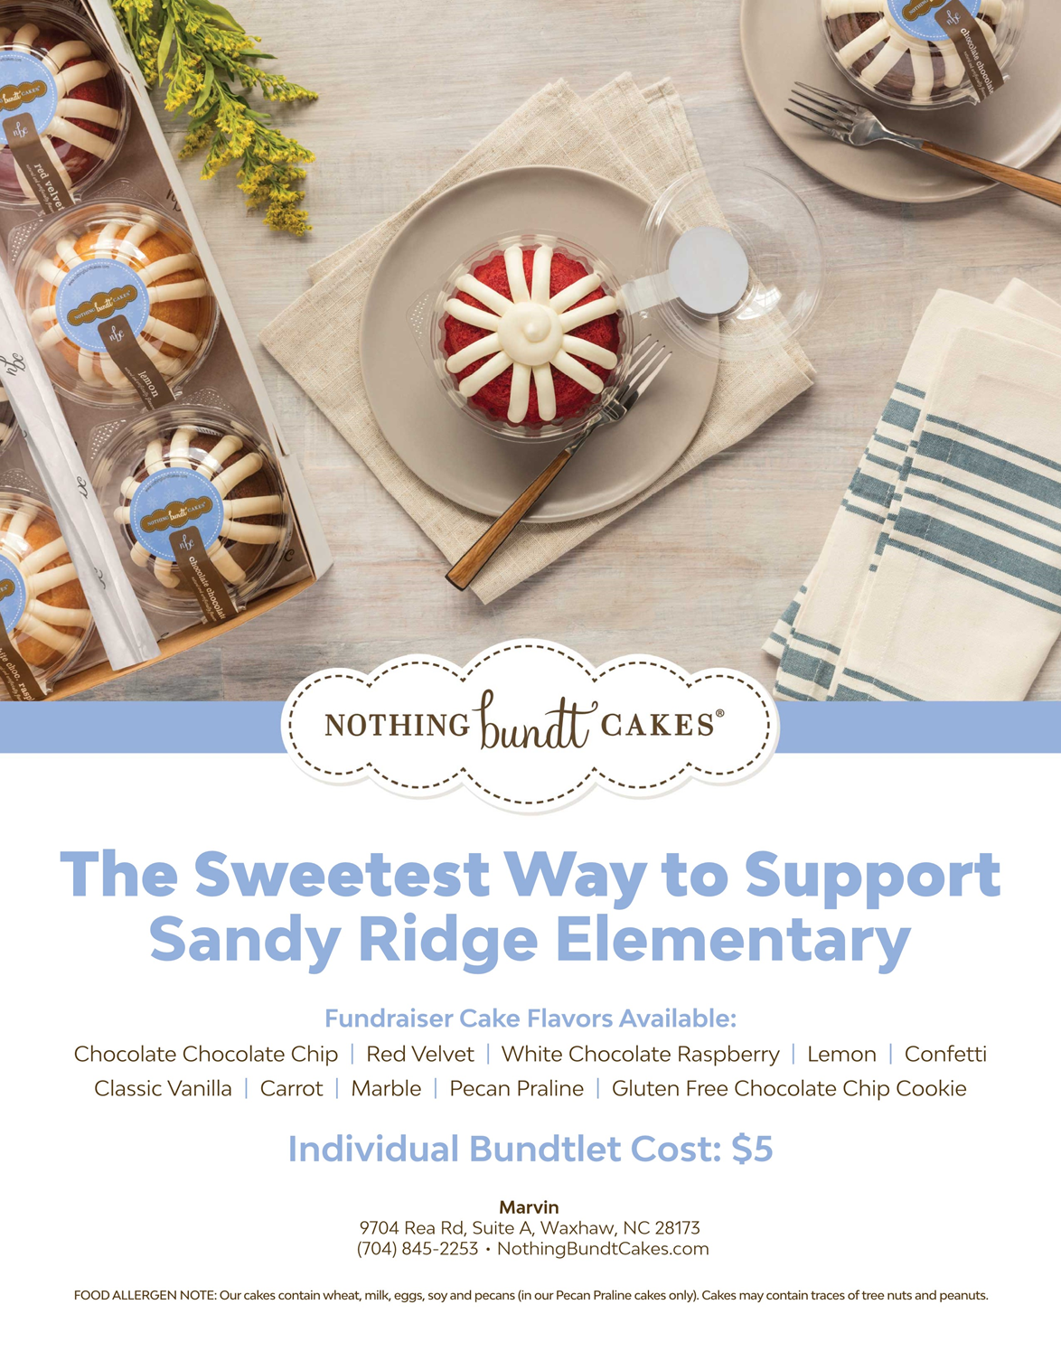

Please fill out and return form with payment by 4/23
ORDERS will be Picked up at SRE on 4/29 from 4-7pm

Name:____________________________________________________
Phone #__________________________________

FLAVOR | Quantity | X $5 | TOTAL
Chocolate Chip |  | x $5
Red Velvet |  | x $5
White Chocolate Raspberry |  | x $5
Lemon |  | x $5
Confetti |  | x $5
Classic Vanilla |  | x $5
Carrot |  | x $5
Marble |  | x $5
Pecan Praline |  | x $5
GF Chocolate Chip  Cookie |  | x $5
TOTAL

Cash/Checks only. Please make checks payable to SRE PTO.
This will be a drive thru pickup event.

