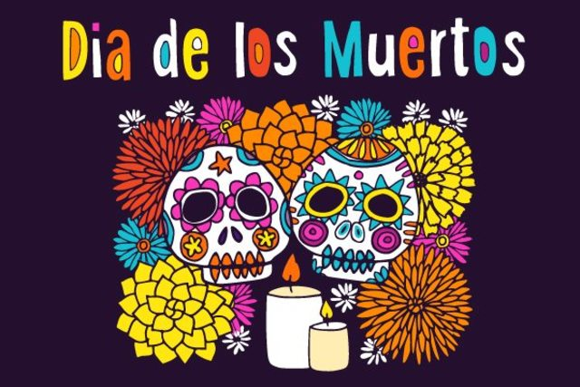

Day of the dead celebration
San juan elementary
Presenting / presentando
“coco”
October/Octubre 26^{th,} 5-8pm
- Face painting / Pintura de la cara
- Food / Comida
- Art and Costume Contest / Concurso de Arte y Disfraces
- Volunteers/Voluntarios call / llame David Pino elpino1@yahoo.com 619 508-2509

