

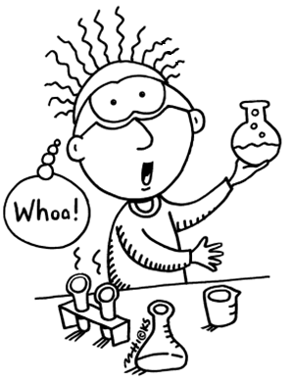

**If you answered yes to any of the above questions,**

**then Kids Are Scientists Too (KAST) is the club for**

**you!**

**Twice a month, student volunteers from Thomas**

**Jefferson High School for Science and Technology**

**(TJHSST) will visit Weyanoke ES and help you discover amazing scientific facts about the world around you.**

**After a short lesson, you get to be the scientist!**

**You’ll be shown how to do your own fun experiment**

**and learn from first-hand experience.**

**Topics you’ll be learning about include:**

* how to extract DNA
* how you digest food
* how fossils form

**Sessions will be held two Fridays per month from approximately**

**4:00-5:00. Please note that although the program is free, transportation will not be provided. If your child is interested,**

**fill out this form and have your child turn it in to the PTA:**

Questions? Please visit our website at [**http://www.kastvirginia.org/tjhsst.html**](http://www.kastvirginia.org/tjhsst.html), or email us at **tjhsstkast@gmail.com**

Child’s name: _______________________________

Child’s teacher and grade: _____________________________

Parent’s name: ______________________________

Parent’s email: ______________________________

Emergency contact phone number: ________________________

Does your child have any allergies? If so, to what? ______________________________________